**Slap-A-Mole**

*Arduino Bar Game Table*

GAME 2334 – Project Development 2

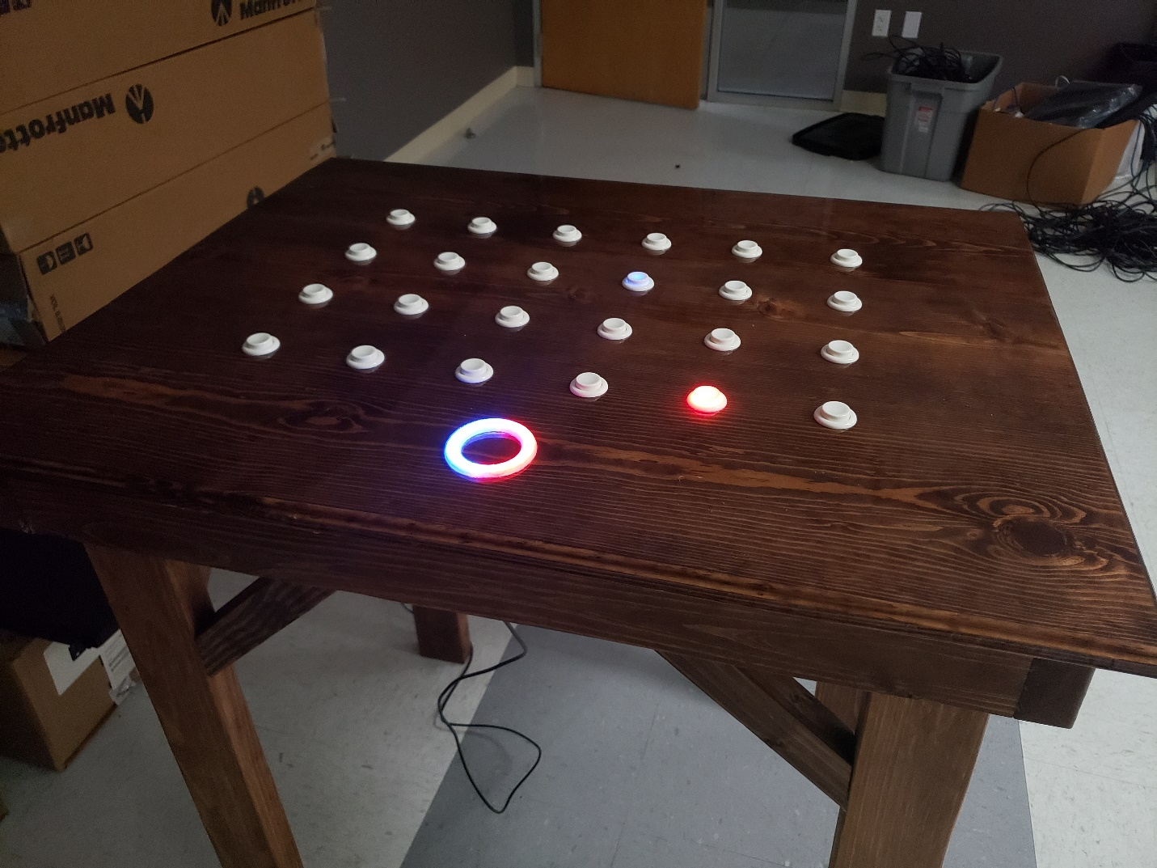

**Index**

Index…………………………………

Overview ……………………………

Programming ………………………..

…………………………………...... 1

…………………………………... 2-3

…………………………………. 4-11

**Overview**

Slap-a-Mole is the final product of a pair of students at HCCS for the second of 2 projects for our Project Development 2 class, GAME 2334, for the DGS program. This valuable class is aimed at teaching some of the skills and teamwork needed to get a larger project done when working with more than just ourselves. Our project is an Arduino-driven game table styled after the arcade game Whack-A-Mole

**Gameplay**

The table has two game modes in its current state: single and two-player. In single-player, the player has 24 seconds to press as many of the lit-up buttons as they can. Their remaining time, and once it runs out their score, is displayed on the dial at the head of the table. In two-player, the players both begin with 12 points. Each time one pressed an LED of their color, red or blue, one point is taken from their opponent and given to them. The game ends when all 24 points are claimed by either of the players. The current point balance of the players is displayed on the dial.

**Controls**

* *Bottom Right & 2nd Bottom Right:* Start Single-Player
* *Top Right & 2nd Top Right:* Start Two-Player

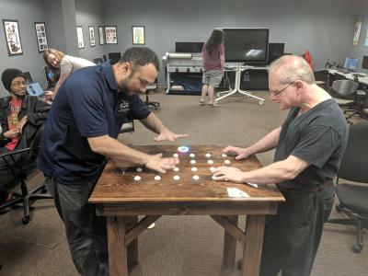

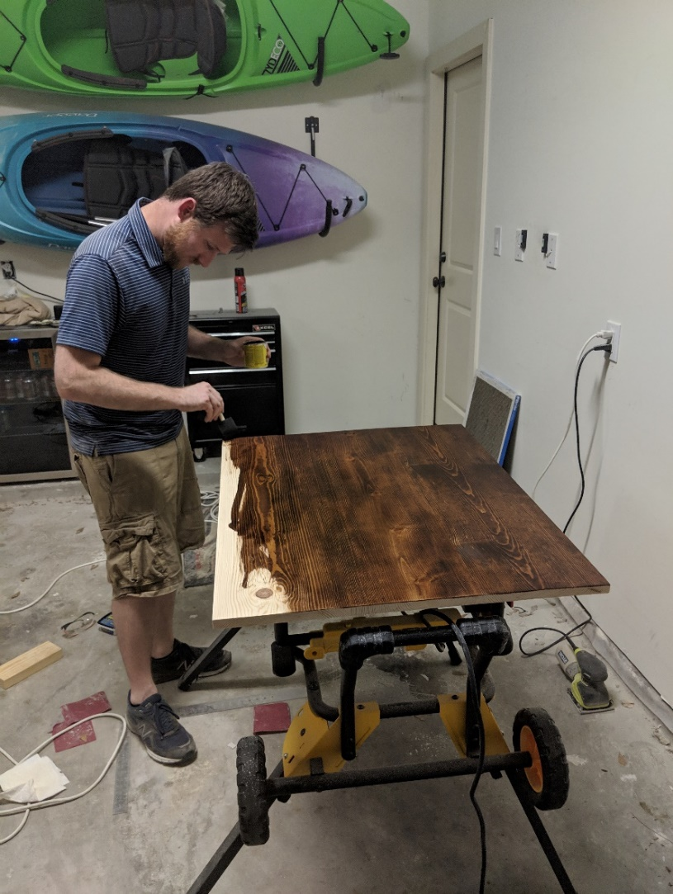 **Material Construction**

The table was made using yellow pine with cherry stain and sealed with a polyurethane glaze. The surface was sanded to bring it closer to a level surface (yellow pine is not known for being straight). The top is attached with hinges for easier access. Arcade switches are used for the buttons for a satisfying sound and feel, with red and blue LEDs embedded to create the glow.

**Tech**

- Arduino Uno

- C

**Team**

*Ryan Brown:* Design & Construction

*Daniel Molski:* Programmer

**Programming**

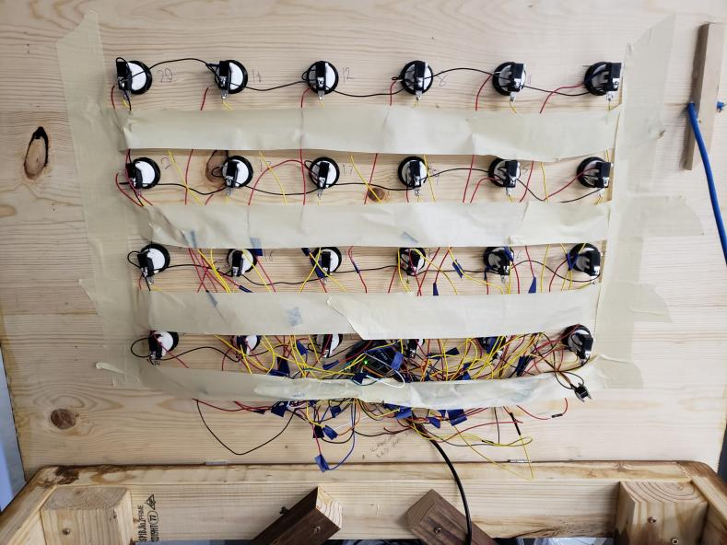

#include <Adafruit_NeoPixel.h>

//system vars

const unsigned int rows = 6;

const unsigned int cols = 4;

const unsigned int area = rows * cols;

unsigned int game_state = 0;

unsigned long current_time = 0;

unsigned long start_time = 0;

unsigned long last_ring_update = 0;

unsigned int animation_state = 0;

const unsigned int animation_lag = 100;

//output vars

const unsigned int led_offset = 2;

unsigned int led_pins[area];

unsigned int led_buffer[area];

const int ring_pin = A1;

const unsigned int ring_leds = 24;

Adafruit_NeoPixel ring(ring_leds, ring_pin, NEO_GRBW + NEO_KHZ800);

char ring_r[ring_leds];

char ring_g[ring_leds];

char ring_b[ring_leds];

char ring_w[ring_leds];

const int buzzer_pin = A0;

const int low_buzz = 523;

const int high_buzz = 784;

int buzz_tone[8];

//input vars

const unsigned int but_offset = 26;

unsigned int but_pins[area];

unsigned int curr_states[area];

unsigned int prev_states[area];

int red_but_pins[area / 2];

int r_curr_states[area / 2];

int blue_but_pins[area / 2];

int b_curr_states[area / 2];

int *blue_leds[area / 2];

int *red_leds[area / 2];

//system functions

void check_All_Buttons()

{

for (int i = 0; i < area; i++)

{

prev_states[i] = curr_states[i];

pinMode(but_pins[i], OUTPUT);

digitalWrite(but_pins[i], HIGH);

pinMode(but_pins[i], INPUT);

curr_states[i] = digitalRead(but_pins[i]);

}

}

void check_RB_Buttons()

{

for (int i = 0; i < area / 2; i++)

{

pinMode(red_but_pins[i], OUTPUT);

digitalWrite(red_but_pins[i], HIGH);

pinMode(red_but_pins[i], INPUT);

r_curr_states[i] = digitalRead(red_but_pins[i]);

pinMode(blue_but_pins[i], OUTPUT);

digitalWrite(blue_but_pins[i], HIGH);

pinMode(blue_but_pins[i], INPUT);

b_curr_states[i] = digitalRead(blue_but_pins[i]);

}

}

//buffer functions

void print_Buffer()

{

for (int i = 0; i < area; i++) digitalWrite(led_pins[i], led_buffer[i]);

}

void fill_Buffer(int state)

{

for (int i = 0; i < area; i++) led_buffer[i] = state;

}

void fill_Row(unsigned int row, int state)

{

for (int i = 0; i < cols; i++) led_buffer[i + cols * row] = state;

}

void fill_Col(unsigned int col, int state)

{

for (int i = 0; i < rows; i++) led_buffer[i * cols + col] = state;

}

void toggle_Row(unsigned int row)

{

for (int i = 0; i < cols; i++)

{

if (led_buffer[i + cols * row] == HIGH) led_buffer[i + cols * row] = LOW;

else led_buffer[i + cols * row] = HIGH;

}

}

void toggle_Col(unsigned int col)

{

for (int i = 0; i < rows; i++)

{

if (led_buffer[i * cols + col] == HIGH) led_buffer[i * cols + col] = LOW;

else led_buffer[i * cols + col] = HIGH;

}

}

void roll_Buf_L()

{

int temp_col[rows];

for (int i = 0; i < rows; i++) temp_col[i] = led_buffer[i * cols];

for (int y = 0; y < rows; y++)

{

for (int x = 0; x < cols - 1; x++)

{

int index = y * cols + x;

led_buffer[index] = led_buffer[index + 1];

}

led_buffer[(y + 1) * cols - 1] = temp_col[y];

}

}

void roll_Buf_R()

{

int temp_col[rows];

for (int i = 0; i < rows; i++) temp_col[i] = led_buffer[(i + 1) * cols - 1];

for (int y = 0; y < rows; y++)

{

for (int x = cols - 1; x > 0; x--)

{

int index = y * cols + x;

led_buffer[index] = led_buffer[index - 1];

}

led_buffer[y * cols] = temp_col[y];

}

}

void roll_Buf_U()

{

int temp_col[rows];

for (int i = 0; i < cols; i++) temp_col[i] = led_buffer[i];

for (int x = 0; x < cols; x++)

{

for (int y = 0; y < rows - 1; y++)

{

int index = y * cols + x;

led_buffer[index] = led_buffer[index + cols];

}

led_buffer[(rows - 1) * cols + x] = temp_col[x];

}

}

void roll_Buf_D()

{

int temp_col[rows];

for (int i = 0; i < cols; i++) temp_col[i] = led_buffer[i + cols * (rows - 1)];

for (int x = 0; x < cols; x++)

{

for (int y = rows - 1; y > 0; y--)

{

int index = y * cols + x;

led_buffer[index] = led_buffer[index + cols];

}

led_buffer[x] = temp_col[x];

}

}

//ring functions

void print_Ring()

{

for (int i = 0; i < ring_leds; i++) ring.setPixelColor(i, ring_r[i], ring_g[i], ring_b[i], ring_w[i]);

ring.show();

}

void clear_Ring()

{

for (int i = 0; i < ring_leds; i++)

{

ring_r[i] = 0;

ring_g[i] = 0;

ring_b[i] = 0;

ring_w[i] = 0;

}

}

void fill_Ring(char r, char g, char b, char w)

{

for (int i = 0; i < ring_leds; i++)

{

ring_r[i] = r;

ring_g[i] = g;

ring_b[i] = b;

ring_w[i] = w;

}

}

void rainbow_Ring(char brightness)

{

for (int i = 0; i < ring_leds / 3; i++)

{

ring_r[i] = brightness - (brightness * i / (ring_leds / 3));

ring_g[i] = brightness * i / (ring_leds / 3);

ring_b[i] = 0;

ring_w[i] = 0;

}

for (int i = ring_leds / 3; i < 2 * ring_leds / 3; i++)

{

ring_r[i] = 0;

ring_g[i] = brightness - brightness * (i - ring_leds / 3) / (ring_leds / 3);

ring_b[i] = brightness * (i - ring_leds / 3) / (ring_leds / 3);

ring_w[i] = 0;

}

for (int i = 2 * ring_leds / 3; i < ring_leds; i++)

{

ring_r[i] = brightness * (i - 2 * ring_leds / 3) / (ring_leds / 3);

ring_g[i] = 0;

ring_b[i] = brightness - brightness * (i - 2 * ring_leds / 3) / (ring_leds / 3);

ring_w[i] = 0;

}

}

void shift_Ring_CW()

{

char temp_r = ring_r[0];

char temp_g = ring_g[0];

char temp_b = ring_b[0];

char temp_w = ring_w[0];

for (int i = 0; i < ring_leds - 1; i++)

{

ring_r[i] = ring_r[i+1];

ring_g[i] = ring_g[i+1];

ring_b[i] = ring_b[i+1];

ring_w[i] = ring_w[i+1];

}

ring_r[ring_leds - 1] = temp_r;

ring_g[ring_leds - 1] = temp_g;

ring_b[ring_leds - 1] = temp_b;

ring_w[ring_leds - 1] = temp_w;

print_Ring();

}

void shift_Ring_CCW()

{

char temp_r = ring_r[23];

char temp_g = ring_g[23];

char temp_b = ring_b[23];

char temp_w = ring_w[23];

for (int i = 23; i > 0; i--)

{

ring_r[i] = ring_r[i-1];

ring_g[i] = ring_g[i-1];

ring_b[i] = ring_b[i-1];

ring_w[i] = ring_w[i-1];

}

ring_r[0] = temp_r;

ring_g[0] = temp_g;

ring_b[0] = temp_b;

ring_w[0] = temp_w;

print_Ring();

}

//game functions

void start_Game()

{

fill_Buffer(LOW);

print_Buffer();

fill_Ring(30, 0, 0, 0);

print_Ring();

tone(buzzer_pin, low_buzz);

delay(400);

clear_Ring();

print_Ring();

noTone(buzzer_pin);

delay(200);

fill_Ring(20, 0, 0, 0);

print_Ring();

tone(buzzer_pin, low_buzz);

delay(400);

clear_Ring();

print_Ring();

noTone(buzzer_pin);

delay(200);

fill_Ring(10, 0, 0, 0);

print_Ring();

tone(buzzer_pin, low_buzz);

delay(400);

clear_Ring();

noTone(buzzer_pin);

delay(200);

fill_Ring(0, 30, 0, 0);

print_Ring();

tone(buzzer_pin, high_buzz);

delay(600);

clear_Ring();

print_Ring();

noTone(buzzer_pin);

delay(100);

}

void end_2p(int winner)

{

fill_Buffer(LOW);

print_Buffer();

if (winner == 1)

{

fill_Ring(30, 0, 0, 0);

for (int i = 0; i < area / 2; i++) *red_leds[i] = HIGH;

}

else if (winner == 2)

{

fill_Ring(0, 0, 30, 0);

for (int i = 0; i < area / 2; i++) *blue_leds[i] = HIGH;

}

else

{

fill_Ring(0, 30, 0, 0);

fill_Buffer(HIGH);

}

print_Ring();

print_Buffer();

tone(buzzer_pin, high_buzz);

delay(200);

clear_Ring();

print_Ring();

fill_Buffer(LOW);

print_Buffer();

noTone(buzzer_pin);

delay(100);

if (winner == 1)

{

fill_Ring(30, 0, 0, 0);

for (int i = 0; i < area / 2; i++) *red_leds[i] = HIGH;

}

else if (winner == 2)

{

fill_Ring(0, 0, 30, 0);

for (int i = 0; i < area / 2; i++) *blue_leds[i] = HIGH;

}

else

{

fill_Ring(0, 30, 0, 0);

fill_Buffer(HIGH);

}

print_Ring();

print_Buffer();

tone(buzzer_pin, high_buzz);

delay(200);

clear_Ring();

print_Ring();

fill_Buffer(LOW);

print_Buffer();

noTone(buzzer_pin);

delay(100);

if (winner == 1)

{

fill_Ring(30, 0, 0, 0);

for (int i = 0; i < area / 2; i++) *red_leds[i] = HIGH;

}

else if (winner == 2)

{

fill_Ring(0, 0, 30, 0);

for (int i = 0; i < area / 2; i++) *blue_leds[i] = HIGH;

}

else

{

fill_Ring(0, 30, 0, 0);

fill_Buffer(HIGH);

}

print_Ring();

print_Buffer();

tone(buzzer_pin, high_buzz);

delay(200);

clear_Ring();

print_Ring();

fill_Buffer(LOW);

print_Buffer();

noTone(buzzer_pin);

}

void end_1p(unsigned int score)

{

fill_Buffer(LOW);

print_Buffer();

fill_Ring(30, 0, 0, 0);

print_Ring();

tone(buzzer_pin, high_buzz);

delay(200);

clear_Ring();

print_Ring();

noTone(buzzer_pin);

delay(100);

fill_Ring(30, 0, 0, 0);

print_Ring();

tone(buzzer_pin, high_buzz);

delay(200);

clear_Ring();

print_Ring();

noTone(buzzer_pin);

delay(100);

fill_Ring(30, 0, 0, 0);

print_Ring();

tone(buzzer_pin, high_buzz);

delay(200);

clear_Ring();

print_Ring();

noTone(buzzer_pin);

fill_Buffer(LOW);

print_Buffer();

clear_Ring();

print_Ring();

start_time = 0;

current_time = millis();

char r = 0;

char g = 0;

char b = 0;

char w = 0;

for (int i = 0; i < score;)

{

current_time = millis();

if (current_time - start_time >= animation_lag)

{

start_time = millis();

if (i % (3 * ring_leds) < ring_leds)

{

r = 0;

g = 50;

b = 0;

w = 0;

}

else if (i % (3 * ring_leds) < 2 * ring_leds)

{

r = 0;

g = 0;

b = 50;

w = 0;

}

else

{

r = 50;

g = 0;

b = 0;

w = 0;

}

ring_r[i % ring_leds] = r;

ring_g[i % ring_leds] = g;

ring_b[i % ring_leds] = b;

ring_w[i % ring_leds] = w;

print_Ring();

tone(buzzer_pin, buzz_tone[i % 8], 3 * animation_lag / 4);

i++;

}

}

delay(2000);

}

void single_Player()

{

int lit_led_1 = rand() % area;

int temp_lit_led = rand() % area;

while (temp_lit_led == lit_led_1) temp_lit_led = rand() % area;

int lit_led_2 = temp_lit_led;

int score = 0;

start_Game();

fill_Ring(0, 30, 0, 0);

print_Ring();

led_buffer[lit_led_1] = HIGH;

led_buffer[lit_led_2] = HIGH;

print_Buffer();

current_time = millis();

start_time = current_time;

last_ring_update = current_time;

for(;;)

{

current_time = millis();

if (current_time - start_time >= 24000) break;

if (current_time - last_ring_update >= 1000)

{

unsigned long d_time = (current_time - start_time) / 1000;

last_ring_update = current_time;

if (d_time < 8)

{

for (int i = d_time; i < 24; i++)

{

ring_r[i] = 0;

ring_g[i] = 30;

ring_b[i] = 0;

ring_w[i] = 0;

}

for (int i = 0; i < d_time; i++)

{

ring_r[i] = 0;

ring_g[i] = 0;

ring_b[i] = 0;

ring_w[i] = 0;

}

}

else if (d_time < 16)

{

for (int i = d_time; i < 24; i++)

{

ring_r[i] = 20;

ring_g[i] = 10;

ring_b[i] = 0;

ring_w[i] = 0;

}

for (int i = 0; i < d_time; i++)

{

ring_r[i] = 0;

ring_g[i] = 0;

ring_b[i] = 0;

ring_w[i] = 0;

}

}

else

{

for (int i = d_time; i < 24; i++)

{

ring_r[i] = 30;

ring_g[i] = 0;

ring_b[i] = 0;

ring_w[i] = 0;

}

for (int i = 0; i < d_time; i++)

{

ring_r[i] = 0;

ring_g[i] = 0;

ring_b[i] = 0;

ring_w[i] = 0;

}

}

print_Ring();

}

check_All_Buttons();

if (curr_states[lit_led_1] == LOW)

{

tone(buzzer_pin, 784, 100);

led_buffer[lit_led_1] = LOW;

score++;

int new_lit = rand() % area;

while (new_lit == lit_led_1 || new_lit == lit_led_2) new_lit = rand() % area;

lit_led_1 = new_lit;

led_buffer[lit_led_1] = HIGH;

print_Buffer();

}

if (curr_states[lit_led_2] == LOW)

{

tone(buzzer_pin, 784, 100);

led_buffer[lit_led_2] = LOW;

score++;

int new_lit = rand() % area;

while (new_lit == lit_led_1 || new_lit == lit_led_2) new_lit = rand() % area;

lit_led_2 = new_lit;

led_buffer[lit_led_2] = HIGH;

print_Buffer();

}

}

end_1p(score);

}

void two_Player()

{

start_Game();

int timeout = 10000;

unsigned long last_button_press = millis();

int red_lit = rand() % (area / 2);

*red_leds[red_lit] = HIGH;

int blue_lit = rand() % (area / 2);

*blue_leds[blue_lit] = HIGH;

print_Buffer();

for (int i = 0; i < ring_leds / 2; i++)

{

ring_r[i] = 30;

ring_g[i] = 0;

ring_b[i] = 0;

ring_w[i] = 0;

}

for (int i = ring_leds / 2; i < ring_leds; i++)

{

ring_r[i] = 0;

ring_g[i] = 0;

ring_b[i] = 30;

ring_w[i] = 0;

}

print_Ring();

int red_score = 12;

int blue_score = 12;

current_time = millis();

while (blue_score < 24 && red_score < 24)

{

current_time = millis();

if (current_time - last_button_press > timeout) return;

check_RB_Buttons();

if (r_curr_states[red_lit] == LOW)

{

last_button_press = millis();

*red_leds[red_lit] = LOW;

tone(buzzer_pin, high_buzz, 100);

ring_r[red_score] = 30;

ring_g[red_score] = 0;

ring_b[red_score] = 0;

int new_lit = rand() % (area / 2);

while (new_lit == red_lit) new_lit = rand() % (area / 2);

red_lit = new_lit;

*red_leds[red_lit] = HIGH;

print_Buffer();

print_Ring();

red_score++;

blue_score--;

}

if (b_curr_states[blue_lit] == LOW)

{

last_button_press = millis();

*blue_leds[blue_lit] = LOW;

tone(buzzer_pin, high_buzz, 100);

ring_r[23 - blue_score] = 0;

ring_g[23 - blue_score] = 0;

ring_b[23 - blue_score] = 30;

int new_lit = rand() % (area / 2);

while (new_lit == blue_lit) new_lit = rand() % (area / 2);

blue_lit = new_lit;

*blue_leds[blue_lit] = HIGH;

print_Buffer();

print_Ring();

blue_score++;

red_score--;

}

}

if (red_score >= 24) end_2p(1);

else if (blue_score >= 24) end_2p(2);

}

int main_Menu()

{

animation_state = 0;

rainbow_Ring(50);

print_Ring();

int counter = 0;

for (;;)

{

check_All_Buttons();

if (curr_states[0] == LOW && curr_states[1] == LOW) return 1;

else if (curr_states[2] == LOW && curr_states[3] == LOW) return 2;

else if (curr_states[4] == LOW && curr_states[5] == LOW) return 3;

else if (curr_states[6] == LOW && curr_states[7] == LOW) return 4;

current_time = millis();

if (current_time - start_time >= animation_lag)

{

start_time = millis();

shift_Ring_CW();

print_Ring();

counter++;

if ((counter - 4) % 8 == 0)

{

if (counter < 8 * 5)

{

led_buffer[0] = HIGH;

led_buffer[1] = HIGH;

}

else

{

led_buffer[2] = HIGH;

led_buffer[3] = HIGH;

}

}

else if (counter % 8 == 0)

{

led_buffer[0] = LOW;

led_buffer[1] = LOW;

led_buffer[2] = LOW;

led_buffer[3] = LOW;

}

if (counter % (8 * 10) == 0)

{

counter = 0;

}

print_Buffer();

}

}

}

//default functions

void setup()

{

pinMode(buzzer_pin, OUTPUT);

ring.begin();

clear_Ring();

print_Ring();

for (int i = 0; i < area; i++)

{

led_pins[i] = i + led_offset;

pinMode(led_pins[i], OUTPUT);

digitalWrite(led_pins[i], LOW);

but_pins[i] = i + but_offset;

pinMode(but_pins[i], INPUT);

curr_states[i] = LOW;

}

buzz_tone[0] = 523;

buzz_tone[1] = 587;

buzz_tone[2] = 659;

buzz_tone[3] = 698;

buzz_tone[4] = 784;

buzz_tone[5] = 880;

buzz_tone[6] = 988;

buzz_tone[7] = 1047;

int blue_offset = 0;

int red_offset = 0;

for (int y = 0; y < rows; y++)

{

if (y % 2 == 0)

{

for (int x = 0; x < cols; x += 2)

{

blue_but_pins[blue_offset] = but_pins[y * cols + x];

blue_leds[blue_offset] = &led_buffer[y * cols + x];

red_but_pins[red_offset] = but_pins[y * cols + x + 1];

red_leds[red_offset] = &led_buffer[y * cols + x + 1];

blue_offset++;

red_offset++;

}

}

else

{

for (int x = 0; x < cols; x += 2)

{

red_but_pins[red_offset] = but_pins[y * cols + x];

red_leds[red_offset] = &led_buffer[y * cols + x];

blue_but_pins[blue_offset] = but_pins[y * cols + x + 1];

blue_leds[blue_offset] = &led_buffer[y * cols + x + 1];

blue_offset++;

red_offset++;

}

}

}

for (int i = 0; i < area / 2; i++)

{

r_curr_states[i] = LOW;

b_curr_states[i] = LOW;

}

}

void loop()

{

clear_Ring();

print_Ring();

fill_Buffer(LOW);

print_Buffer();

if (game_state == 1)

{

single_Player();

game_state = 0;

}

else if (game_state == 2)

{

two_Player();

game_state = 0;

}

else game_state = main_Menu();

}